**“Learning MANAGEMENT SYSTEM”**

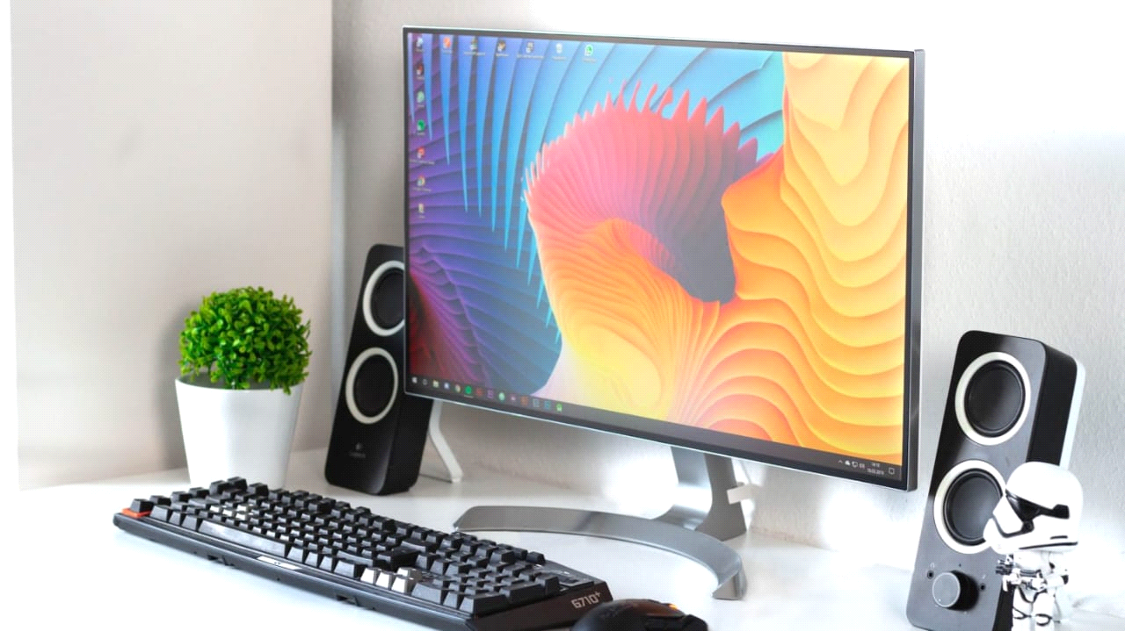

**Project Group Member Name:**

1. **Abhishek Ankush Magar.**
2. **Sudarshan Govardhan Gadekar.**

**Shree Mulikadevi Mahavidyalay,**

**Nighoj.**

**A Project Report On**

**“ Learning Management System”**

**Submitted in partial fulfilment for the award of the**

**degree of**

**“T. Y. B.Sc. (Computer Science)”**

**Submitted By:**

1. **Abhishek Ankush Magar.**
2. **Sudarshan Govardhan Gadekar.**

**Guided By**

**Pro. Gorde R.G.**

**Savitribai Phule Pune**

**University**

**Acadamic Year 2024-2025**



**Department of B.Sc.(C.S)**

**\*CERTIFICATE\***

This is to certify that project entitled **“ Learning Management System”** is submitted by –

Abhishek Ankush Magar

Sudarshan Govardhan Gadekar

Students of Bachelor of Computer Science Department , Shree Mulikadevi Mahavidyalay,Nighoj in fulfilment of the requirement for the Bachelors of(Computer Science) Degree of Savitribai Phule Pune university, is a record of students own study carried under my supervision and Guidance.

**Project Guide : Head Of Department:**

**Suroshe Mam Pro.Gorde R.G.**

**Internal Examiner: External Examiner:**

**Exam Date :-**

**Acknowledgement**

This is a great opportunity to acknowledge and to thanks all those persons without who’s support and help this project would have been impossible. We would like to add a few heartfelt words for the people who were part of this project in numerous ways. We would like to thanks to my project guide Hod. Gorde Madam for her indefatigable guidance, valuable suggestion & moral support, constant encouragement and contribution of time for the successful completion of project work. We are very greateful to her, for providing all the facilities needed during the project development. At the outset, I sincerely thank all faculty members of institution for extra efforts to make our session on line inspire of all idea. We thank our counselors for indispensable support and encouragement through the project. we would like to thank all those who helped me direct or indirectly. Last but not the least, we would like to acknowledge the ongoing support of my parents and my family members, who patience and encouragement during these long days and nights have been paramount in making this project a reality.

Thank you.

**INDEX**

|  |  |  |
| --- | --- | --- |
| Sr. No | Title | Page.no |
| 1 | Introduction to system | 6 |
| 2 | Scope of system | 8 |
| 3 | Objectives of system | 9 |
| 4 | Facts finding technique | 10 |
| 5 | Feasibility study | 11 |
| 6 | Hardware and software requirements | - |
| 7 | Entity relationship Diagram | 12 |
| 8 | Data Flow Diagram (context level) | 13 |
| 9 | Data Flow Diagram (first level) | 14 |
| 10 | Class Diagram | 15 |
| 11 | Use case Diagram | 16 |
| 12 | Sequence Diagram | 17 |
| 13 | Activity Diagram | 18 |
| 14 | Component Diagram | 19 |
| 15 | Data Dictionary | 20 |
| 16 | Form Design |  |
| 17 | Input and Output screen |  |
| 18 | Reports |  |
| 19 | Advantages |  |
| 20 | Limitations |  |
| 21 | Future Inhancement |  |
| 22 | Conclusion |  |
| 23 | Reference |  |

**INTRODUCTION**

In this project an attempt is made to design a computer system for the CYBER CAFÉ that makes the management of recording user details, internet usage and billing much easier. The objective of this software is to maintain the details of users, cabins and login history. Through this system we provide facility of prepaid and postpaid accounts respectively for Account Users and Walkthrough Users. It has the features like adding, viewing, editing of user details, cabin details, recharge option for prepaid users, billing, tariff settings, etc.

The Software powered by JAVA assures clear and efficient services to the agency. This easy-to-operate system helps to access and modify user details, provides efficient billing facility. The software is designed to provide Reliable and error free information. The database is driven by My SQL thus providing portability. Anyone having an account with the system can have access to internet by logging into the client machine using a given username and password. Account users can login only if they have sufficient balance in the account. Otherwise they will have to recharge their account using the recharging facility at the administrator side. To ensure enhanced security user account creation, editing, etc are available only at the administrator side.

On successful login the user can load browser and can have access to internet. The login time displayed on the login screen may help the users manage their usage. On logout the internet usage charges and available balance in the account (in case of account users) will be displayed.

**2.SCOPE OF THE PROJECT**

The system we propose has great scope in the current real time situation. The cyber crime monitoring system can be enhanced to an extent by implementing this system. Most of the firms and establishments are being

computerized in order to ease the tasks to be performed. The internet cafés unfortunately are rarely computerized. We aim through this venture, a better reliable solution. In the primary stage of feasibility study itself we received an exquisite response and so we plan to go ahead with our project

**OBJECTIVES**

**ACHIEVEMENTS EXPECTED THROUGH THE PROJECT**

**•** Comparing to existing manual system, it performs at a faster pace.

• System gives better feed back.

• 'Timely and accurate information are available.

• The system provides greater processing speed consistency.

•Chances oferrorsaremuch low.

• Provides high security hte system and hence unauthorized user can be prevented

• Time taken for overall process is reduced.

• Forms are very user friendly.

• Ease of operation.

**SYSTEM ANALYSIS**

System analysis is for finding out what happens ni existing system deciding on what changes and new features are required and defining exactly what the proposed system must be. The process of system analysis is largely

concerned with determining, developing and agreeing to the user's requirements. It provides prime opportunity to communicate well with the user and conceive a

joint understanding of what a system should be doing together with a view of relative importance ofthe system facilities usinginteractive techniques.

**PROPOSED SYSTEM**

The Cyber Café Management System which we design is in the same line of the existing system. No procedural changes are made to the existing system except the login process done by the customers.

The new system we develop has 2 modules. One module is to be installed ni the server computer and the second module is to be installed in every client computers. In server module the staff should login with their username and password. The first entering window contains a flex grid which will display all

the cabins. If any customer logs ni any client computer, the details of the user including name and address will be displayed ni this grid.

If any of the client computers is not in working condition, there is facility to remove it from allocation process. After accomplishing the maintenance it can

be added back to the cabin settings.

When a new customer comes for browsing, an account is created for him.

The account can be of t w o apes. "Account user" and "Walkthrough user". An account user must pay a minimum amount of Rs.50 for the creation of account.

While walkthrough users have to pay only after their usage. Account users can use the internet for lower tariffs which can be adjusted from the menu atfri' settings

The usage amount will be deducted from their account's balance. In case their credit amount is lower. the customer should recharge their account. Recharge option are available at recharge menu.

An account contains information about the

user's name, address, identification etc. They should have aunique user-id and password. Using this

user-id and password they can log ni from the client computers. In case any user forgets his password. it can be recovered and edited from the edit option in menu named 'Account setting.

Different reports are included regarding users, their login time, logout time, used machine etc. In case fi any malpractices have occurred from the cafe, it can be identified by checking the user report. Daily report provides details regarding all the user details of a day. Reports of a specific user can be viewed using their user-id. Similarly machine

wise reports are also there, which helps to find all the users who have used a specific computer.

Since information regarding the users is needed for further checking, an account can be deleted only after 5 years from the last login date.

**FEASIBILITY STUDY**

During system analysis, the feasibility study of the proposed system is ot be carried out. This is to ensure that proposed system is not a burden to the

company. This study can be categorized into three types. They are:

**ECONOMIC FEASIBILITY STUDY**

This study is carried out to check the economic impact that the system will

have on the organization. The amount of fund that the company can pour into the research and development ofsystem is limited, the expenditures must be justified.

Thus the developed system was wel within the budget and this was achieved because most of the technologies used are freely available. Only customized products had to be purchased.

**TECHNICAL FEASIBILITY STUDY**

This study is carried out to check the technical facility, that is, the technical requirements of the system. Any system developed must not have a high demand on the available technical resources. This developed system has modest technical requirements, as only minimal or null changes ARE required for implementing this

system.

**SOCIAL FEASIBILITY STUDY**

This aspect of study is to check the level of acceptance of the system by the user. This includes the process of training the system but must accept it as a necessity. The levels of acceptance by the users solely depend on the methods that are employed to educate the user about the system and make him familiar with it. His level of confidence must be raised so that he isalso able to makesome constructive criticism, which is welcomed.

**SYSTEM CONFIGURATION**

**1.Hard Disk:128GB&above**

**2.Processor:PIIIonwards**

**#Minimum Hardware Requirement:**

•RAM:256MB & above

•OperatingSystem: Windows 11 &onward

•Frontend: Html, CSS.

•Backend: Jsp, MySQL.

#Software Requirement

•Server:ApacheTomcat.

**ER DIAGRAM:**

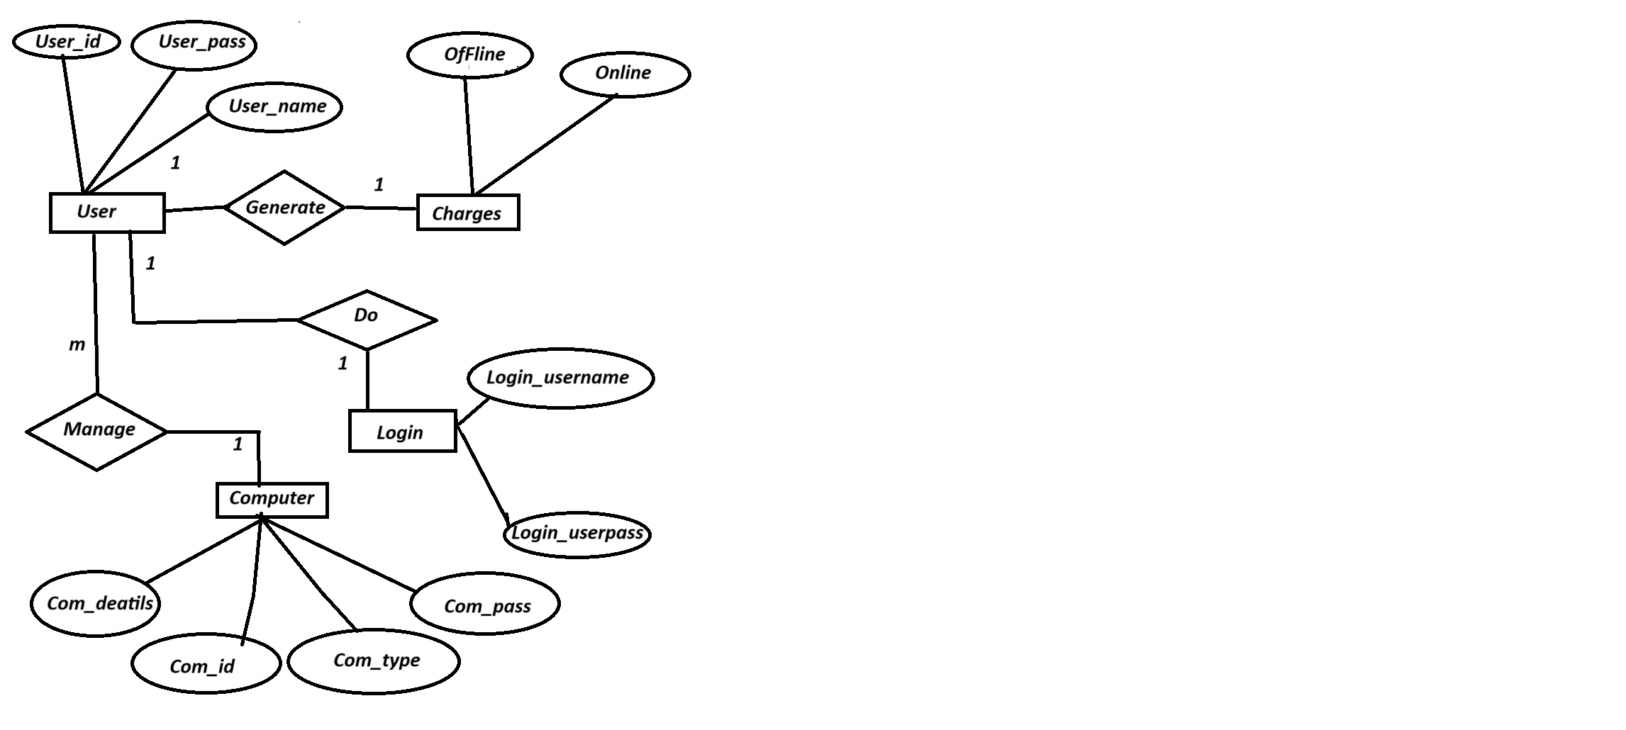

\***Data Flow Diagram(Context Level)**

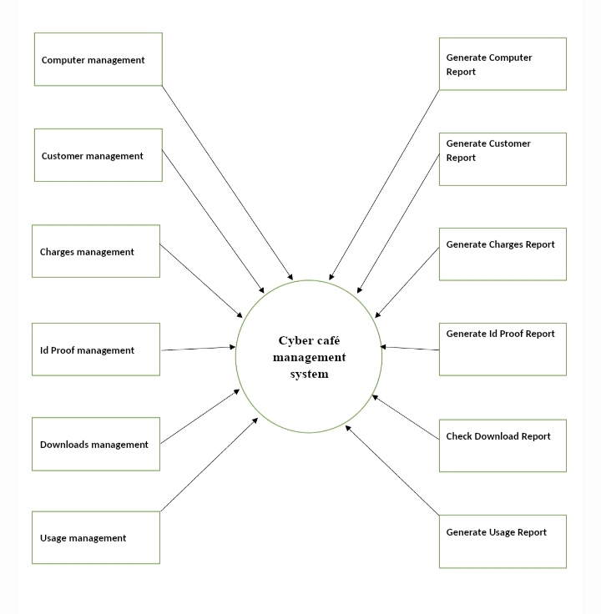

**Data Flow Diagram(First Level):**

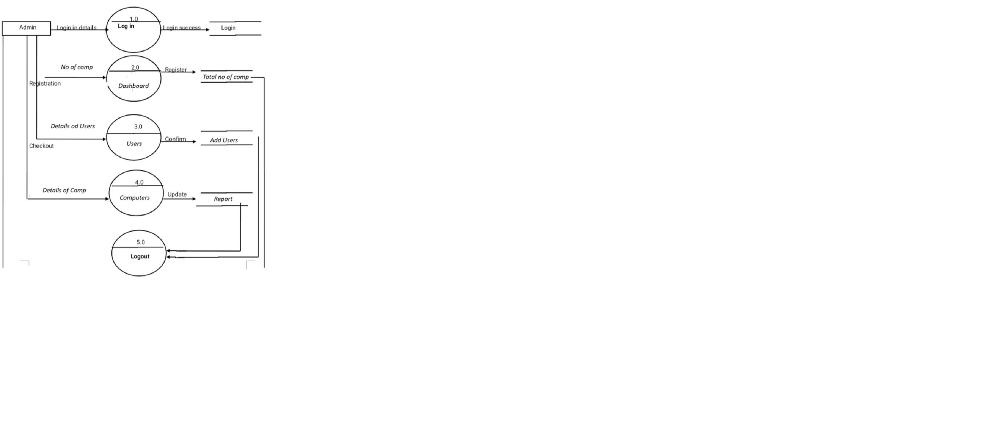

**Class Diagram**

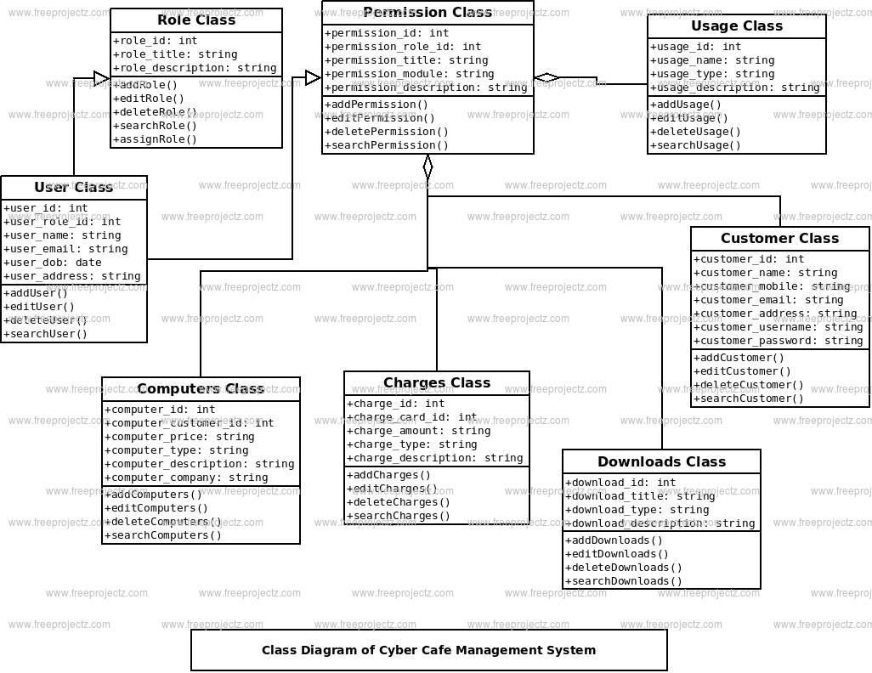

**Use Case Diagram**

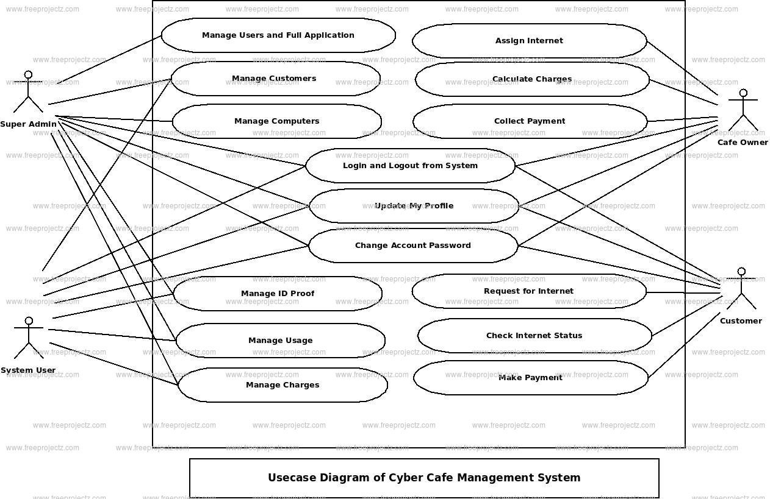

**Sequence Diagram**

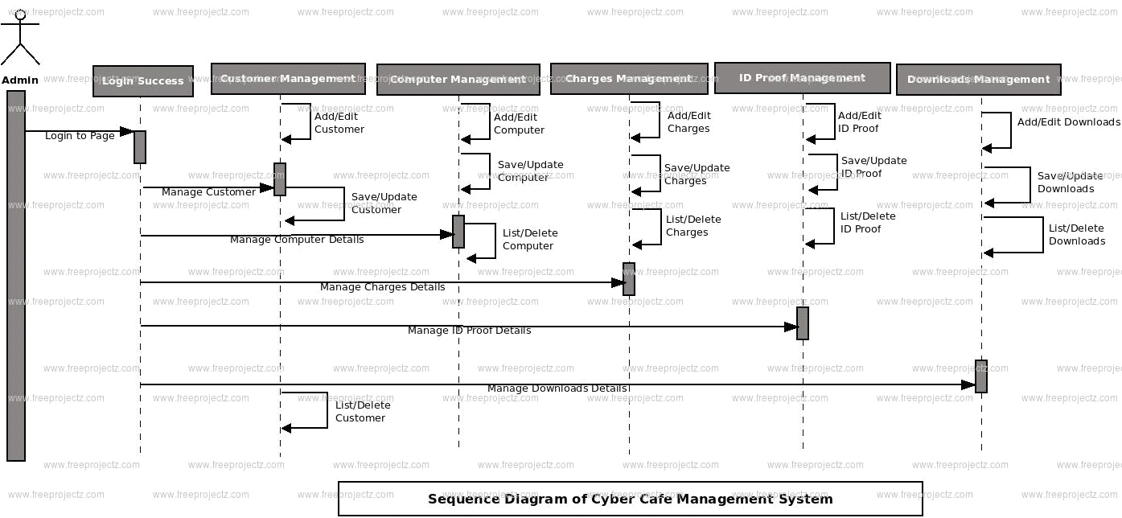

**Activity Diagram**

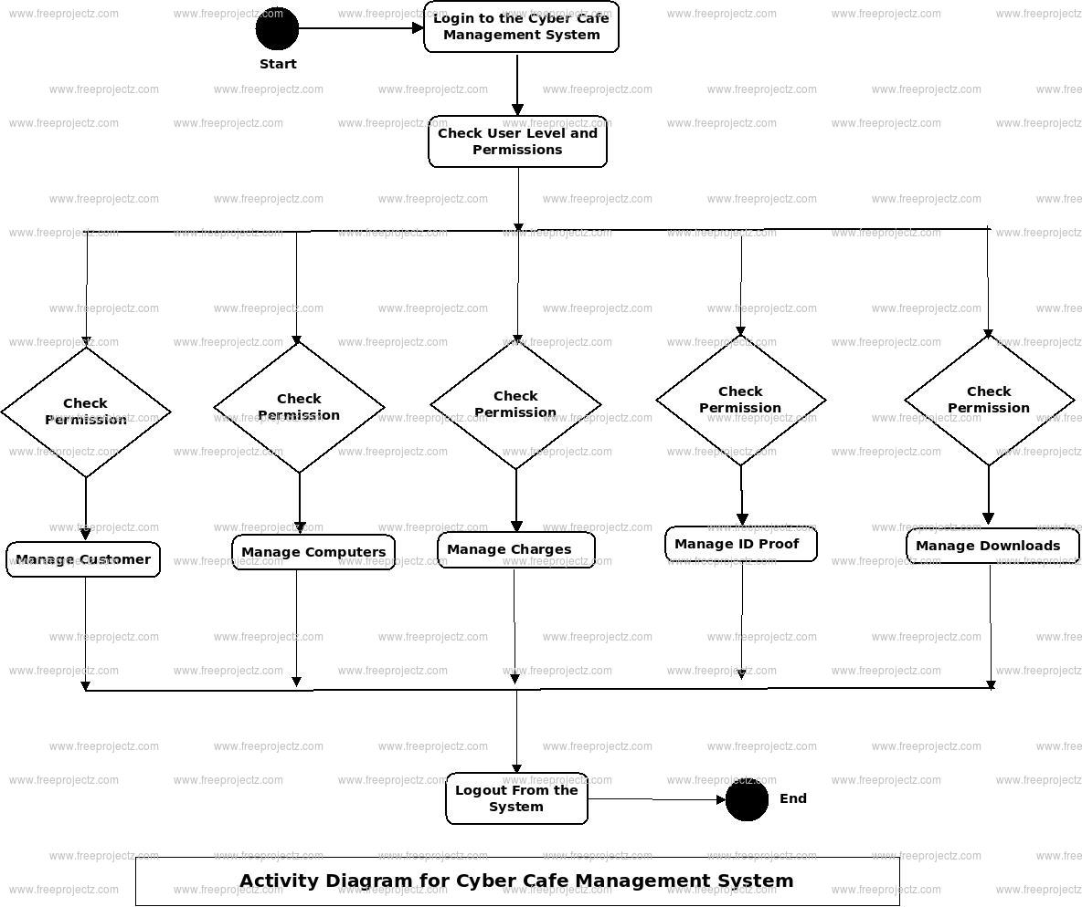

**\*Component Diagram:**

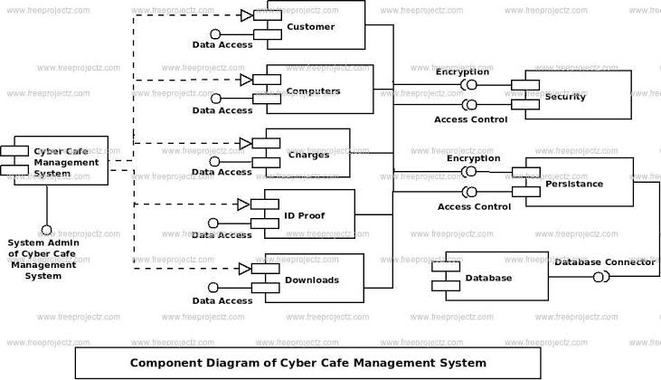

**Data Directory**

Balance

|  |  |  |
| --- | --- | --- |
| **FIELD NAME** | **TYPE** | **Description** |
| **Bid** | **Number** | **Id of Balance** |
| **B date** | **Date** | **Birth Date** |
| **Aval balance** | **Number** | **Available Balance** |
| **Tottime** | **Time** | **Total Time** |
| **Login time** | **Time** | **User’s Login Time** |
| **Logout time** | **Time** | **User’s Logout Time** |

Administretor

|  |  |  |
| --- | --- | --- |
| **FIELD NAME** | **TYPE** | **Description** |
| **A_lname** | **Text** | **Administration Name** |
| **A_Pwd** | **Text** | **Administration Password** |

Member

|  |  |  |
| --- | --- | --- |
| **FIELD NAME** | **TYPE** | **Description** |
| **M id** | **Number** | **Member’s ID** |
| **M name** | **Text** | **Member’s Name** |
| **Day** | **Text** | **Day** |
| **Month** | **Text** | **Month** |
| **Year** | **Text** | **Year** |
| **Gender** | **Text** | **Member’s Gender** |
| **Addr** | **Text** | **Member’s Address** |
| **Type** | **Text** | **Member’s Type** |
| **Mobile** | **Text** | **Member’s Mobile** |
| **Email** | **Text** | **Member’s Email** |
| **Day1** | **Number** | **Member’s** |

**Test Plan for CyberCafe System**

* **General Information**

* Summary :

We are testing the application of Sales management System which maintains and helps in day-to-day transaction of Sales Department.

* Environment and Pre-Test Background :

This application is being tested in SIBAR (MCA Dept) Computer Lab. No prior testing has been done on this application.

* **Test Objective :**

* Authentication and Authorization.
* Member Details
* Time Details
* Balance Details.
* Bill Details.
* Report Details**.**
* **Expected Defects :**

* Open Defects
* Close Defects
* Known Defects

Screen Shots:

*Login Screen *

**II ADMINISTRATOR SIDE**

1. **LOGIN PAGE**

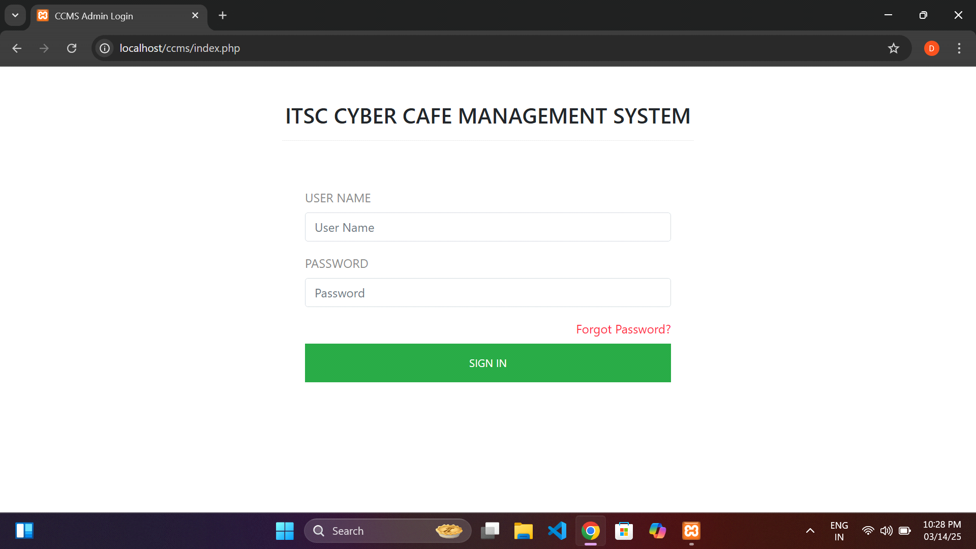

**ii.HOME PAGE**

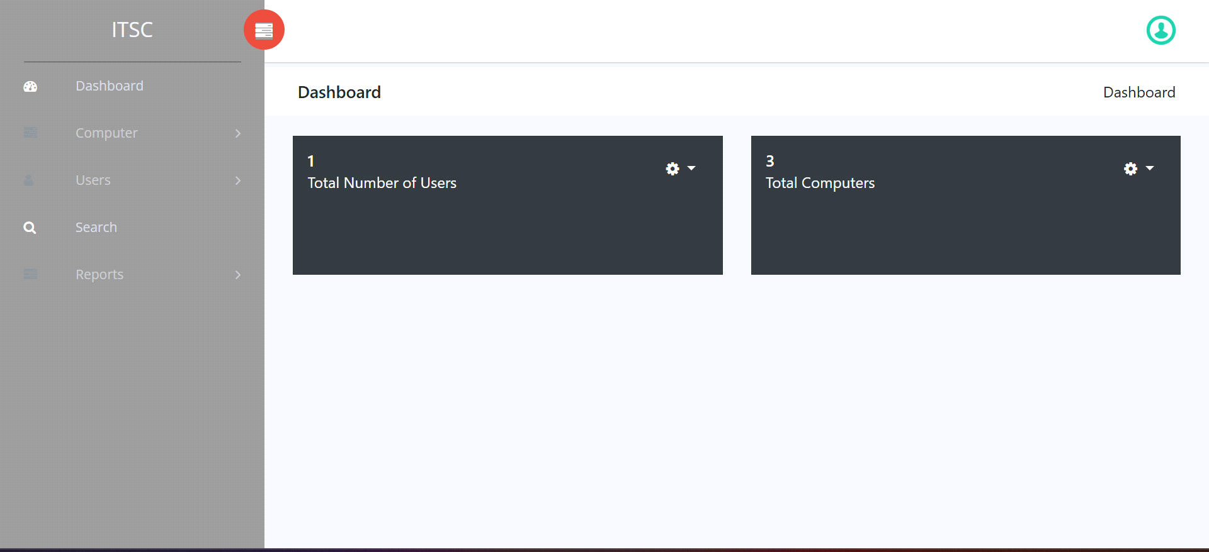

**\*\* COMPUTER.\*\***

**1.Add Computers.**

**i.Computer Details.**

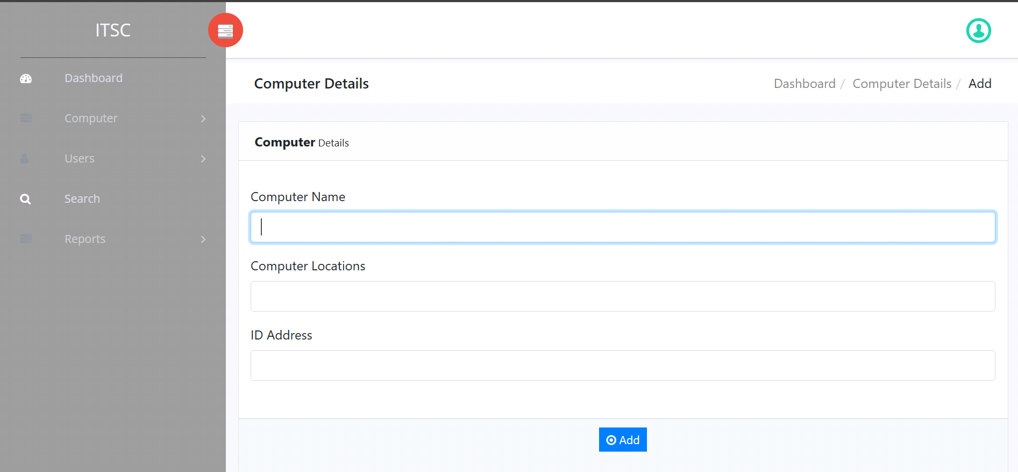

**2.Manage Computers.**

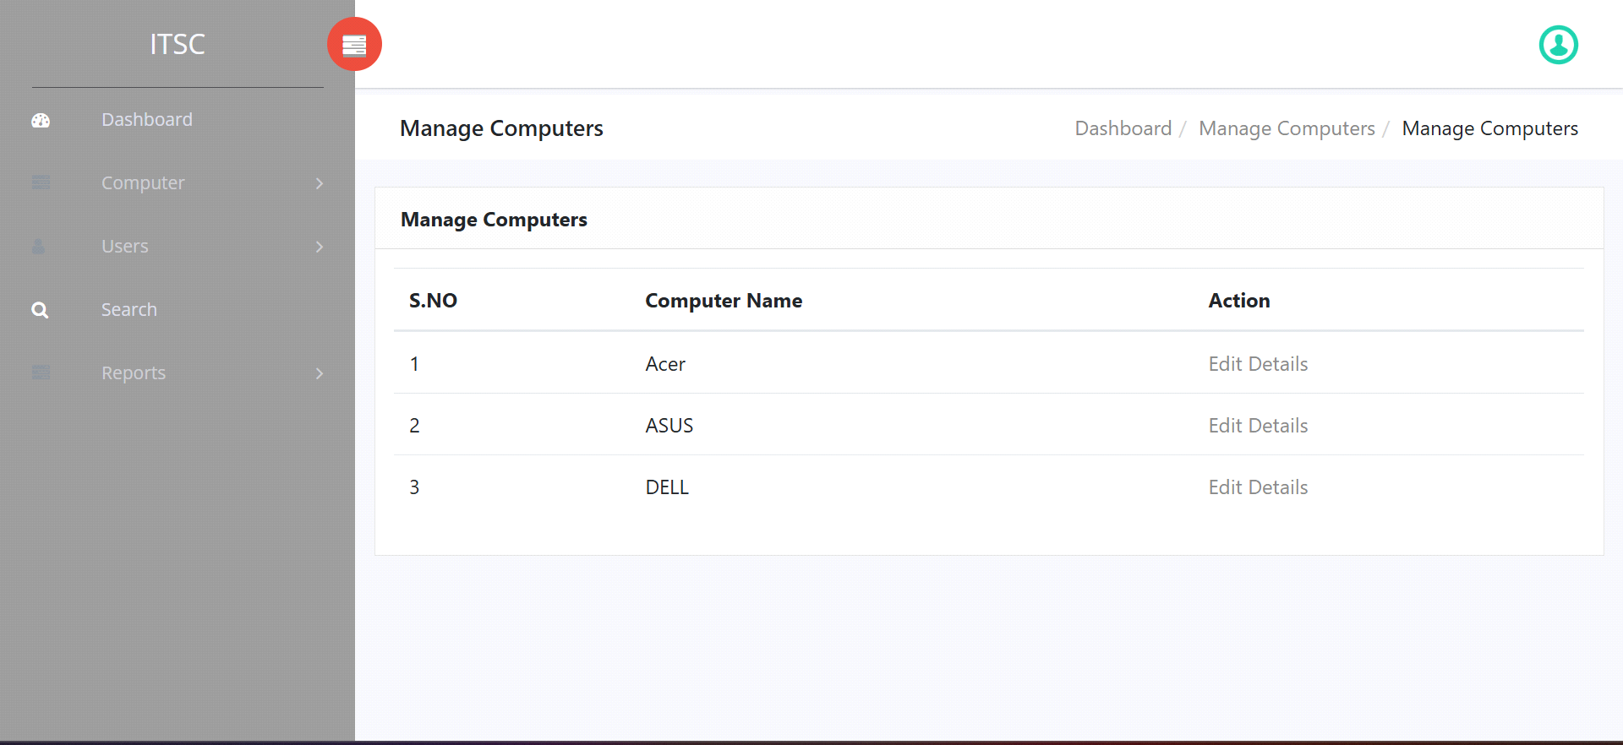

**3.Users:**

**i.Users Detail.**

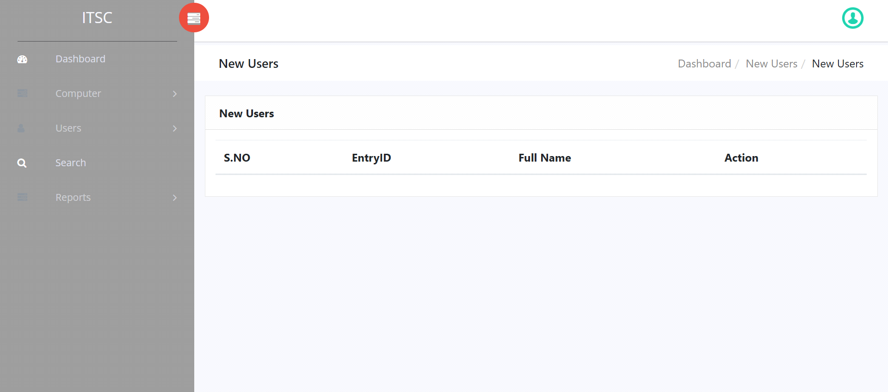

ii.Manage New Users.



**iii.View Old Users:**

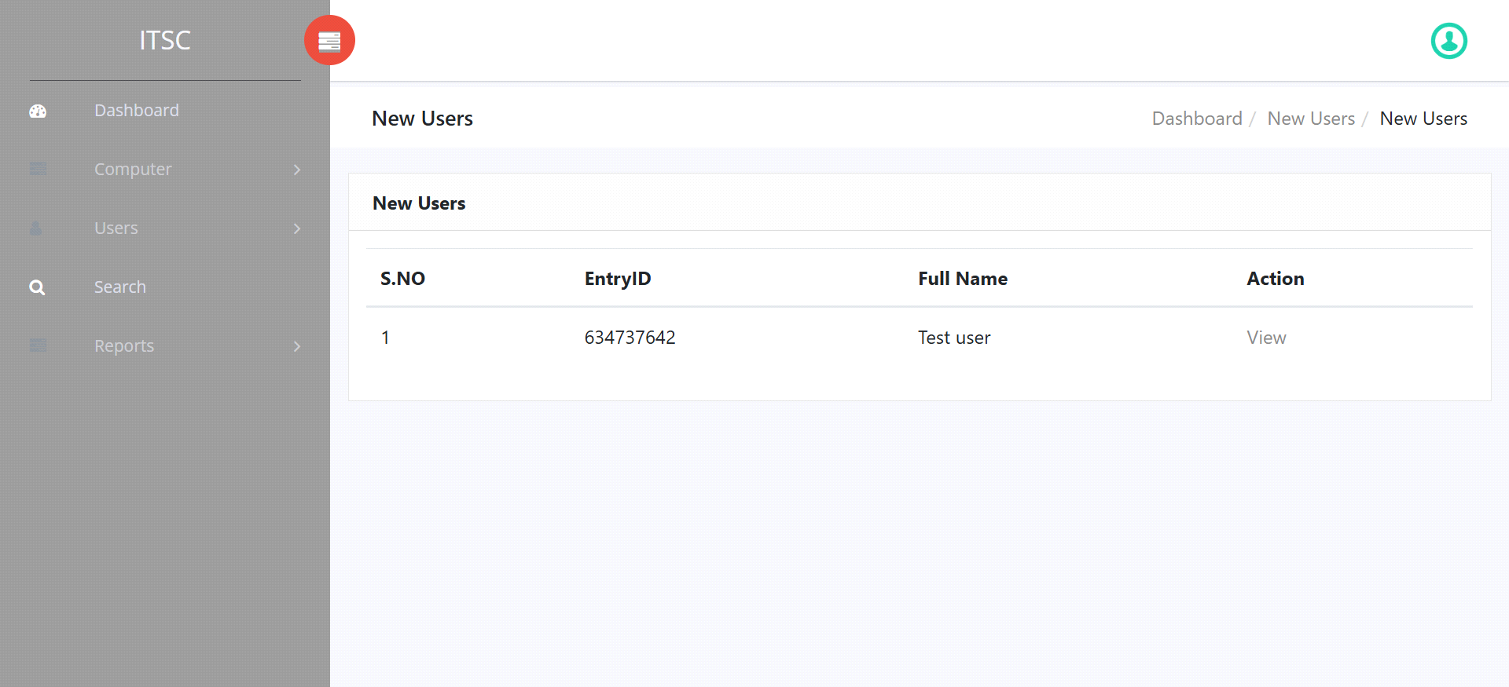

**4.Search.**

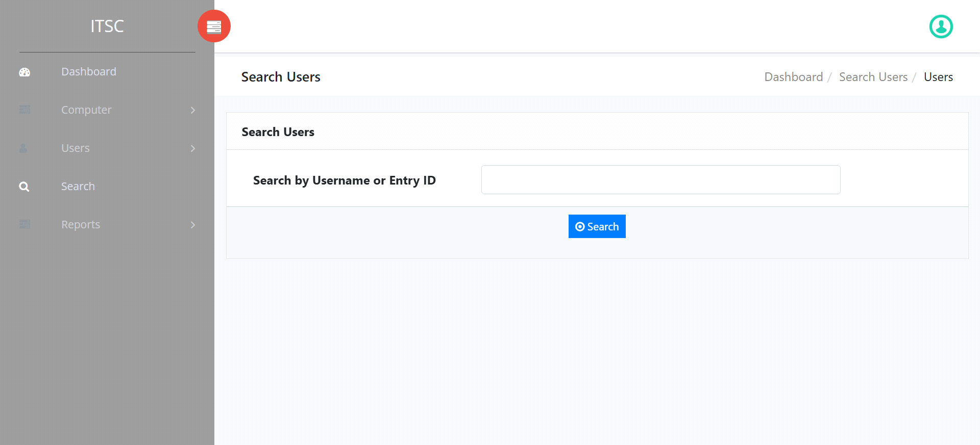

**5.Report.**

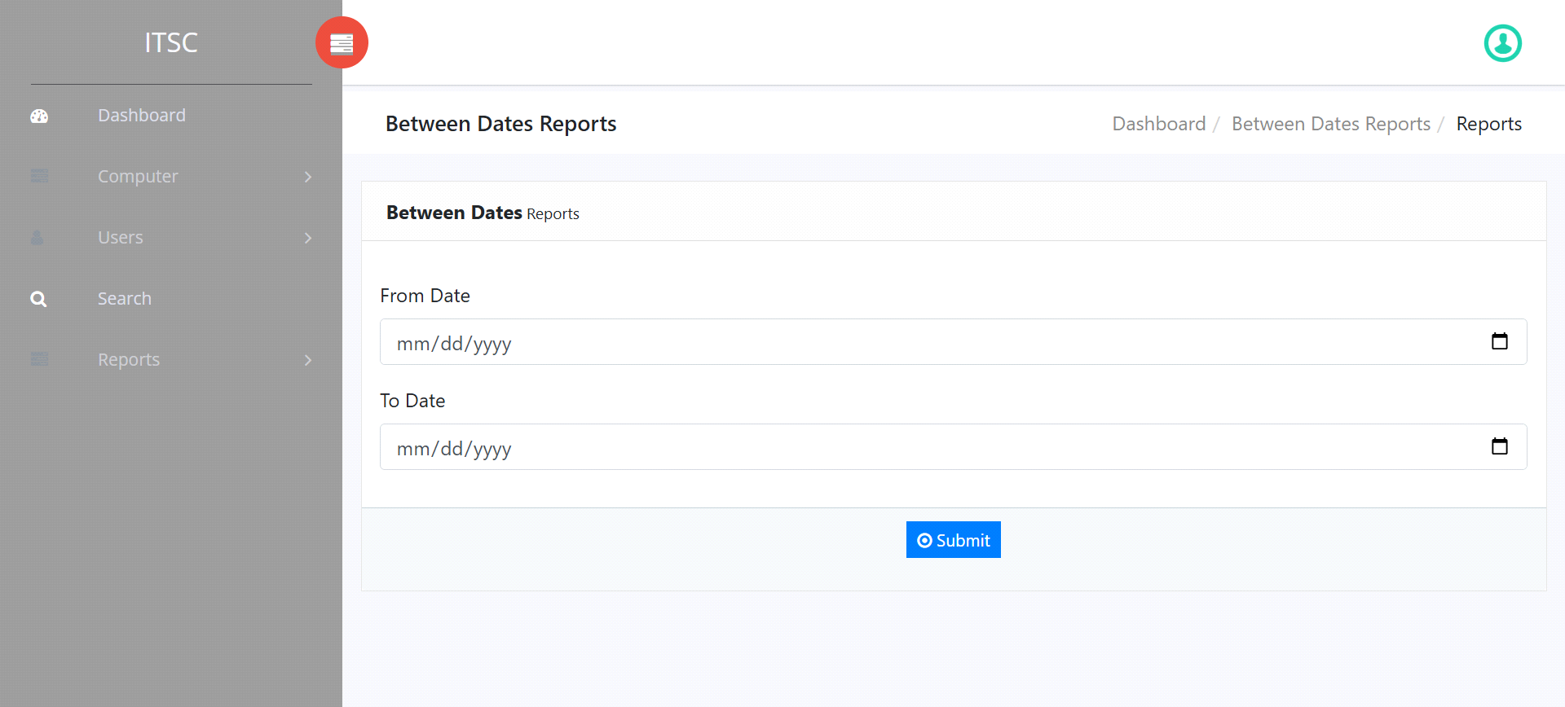

**\*Admin Profile.**

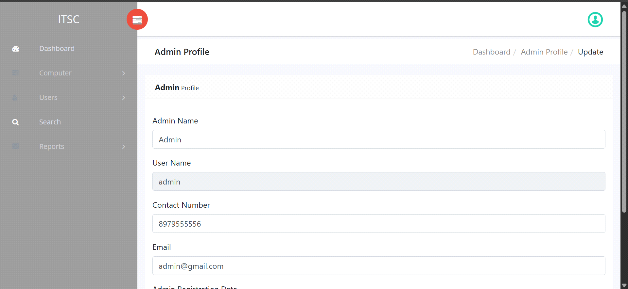

**\*Change Password.**

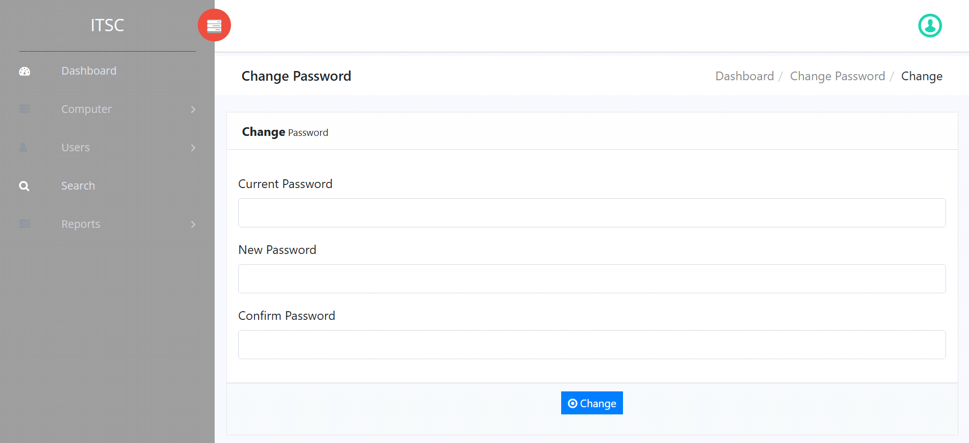

**\*Reset**

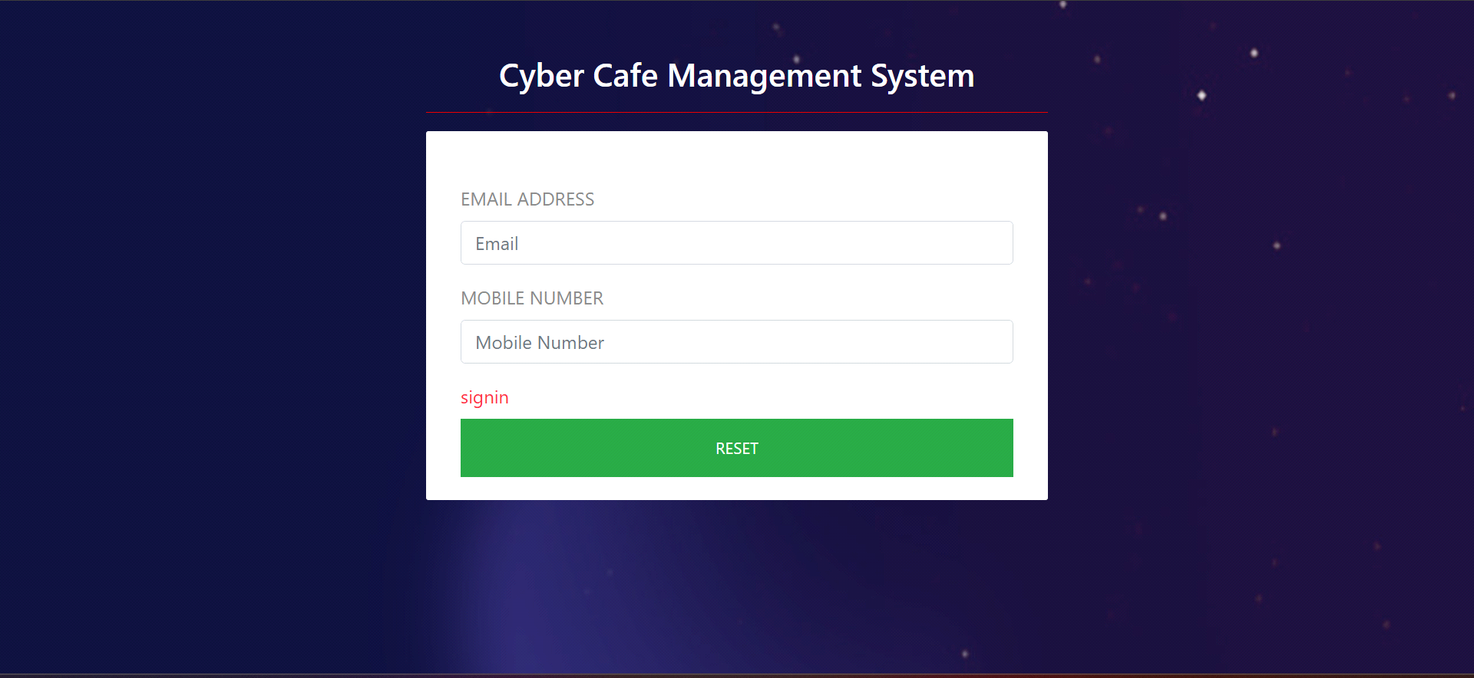

**\*Logout.**

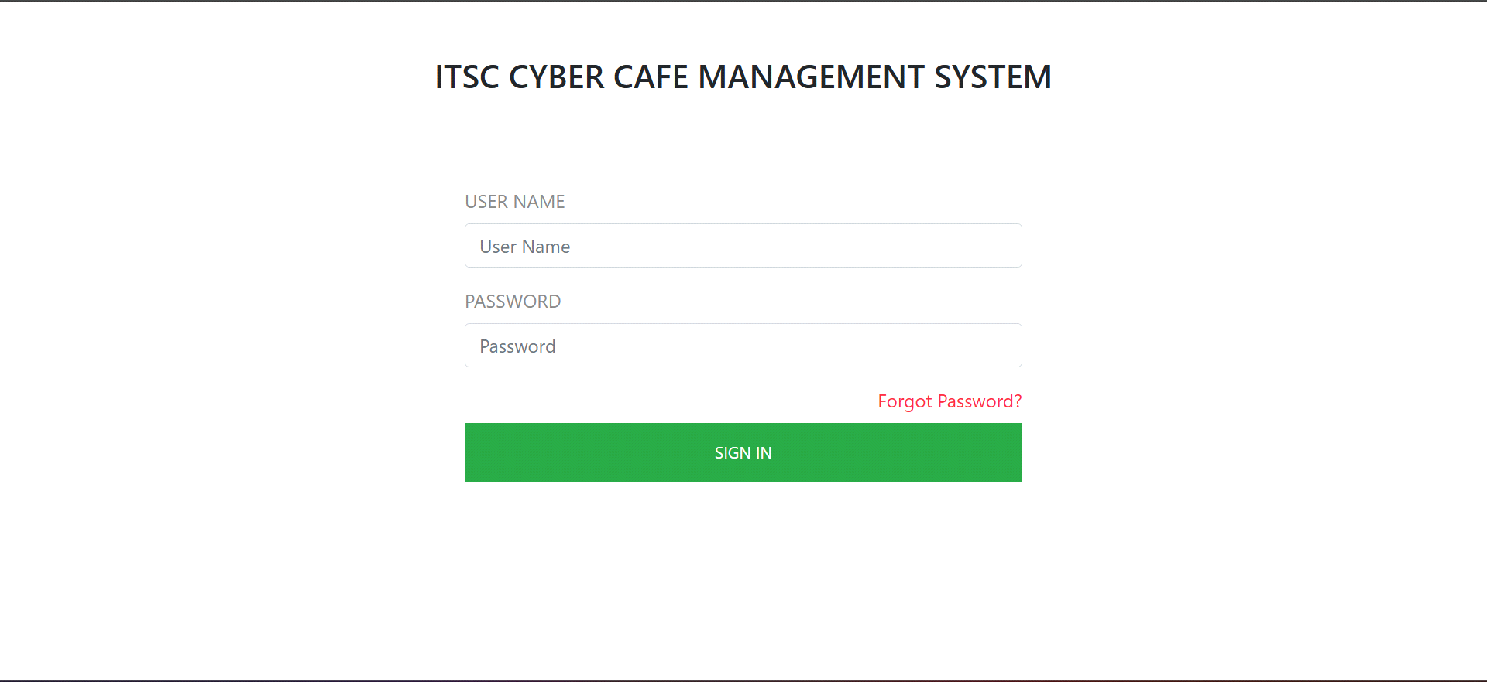

**LIMITATIONS AND FUTURE**

**ENHANCEMENTS OF THE SYSTEM**

**LIMITATIONS :**

The most important limitation of the existing system is , it is Manual system.

**Drawbacks of Manual System:**

* Time required for validation and updating is more.
* Accuracy is less and incomplete.
* Searching is difficult.
* Repetition of work is going on.
* Keeping track of cabin status is tedious job.

**FUTURE ENHANCEMENTS:**

The computerized “Cyber Café Management “ is made with intention to make easy to maintain the records and minimize the drawbacks of the system.

**Advantages of computerized system over manual system are:**

* Computerized system is completely automated thus user can operate easily.
* Time required is very less to makes and search the records.
* Computerized system generates online reports.
* It reduces the data consistency and redundancy.
* Computerized system is very helpful to display all records.

**Conclusion**

*The cyber cafe management system offers several advantages, including streamlined operations, enhanced security, and improved customer experience. By automating tasks such as user authentication, billing, and resource allocation, it increases efficiency and reduces human error. Additionally, features like session monitoring and internet usage tracking help ensure compliance with regulations and protect both customers and the business.*

**Reference**

* [www.Javapoint.com](http://www.javapoint.com/)
* [www.tutorial](http://www.tutorial/)point.com
* [**www.wikipedia.com**](http://www.wikipedia.com/)
* [**www.google.com**](http://www.google.com/)